**DS Capstone**

**AI-Powered Supply Chain Resilience Index (SCRI) for E-Commerce and Retail**

Team Name: **Chain Vision**

**Sai Kamal Makthala**(16354662): Led Transformer-based model development and optimization. (DL Engineer)

**Likhitha Neerati**(16359266): Designed explainability framework using LIME and SHAP. (AI Engineer)

**Sindhu Mukkara**(16359054): Developed data ingestion pipeline and dashboard UI. (UI Developer)

**Lalitha Rani Palakaluri**: Focused on API integration and deployment using Flask/Streamlit.(Data Engineer)

**Diagrams and Descriptions:**

**1.Advanced AI/ML Model Diagram:-**

Objective:

Architecture of AI/ML models, including Transformers, LLMs and RAG.

**Diagram link:**

<https://drive.google.com/file/d/10VUOpaGj2A0A4WAmvpD4jKF7B-e1Le3r/view?usp=sharing>

**Description:-**

The flowchart illustrates the end-to-end workflow of the AI-powered Supply Chain Resilience Index (SCRI) system for e-commerce and retail, focusing on weather-induced disruptions. It details the sequential process, starting from data collection (weather, logistics, customer, and retailer data) to data preprocessing (cleaning, normalization, and retrieval-augmented generation).The AI Models (LLMs, RAG pipelines, and Stable Diffusion) process this data to generate insights, recommendations, and risk alerts. The Decision-Making & Risk Assessment stage computes the Resilience Index Score, evaluates mitigation strategies, and stores results in vector databases (FAISS, Weaviate, or Pinecone).The User Interaction & Visualization module delivers insights via Streamlit dashboards, chat interfaces, and real-time WebSockets & Streaming APIs. Users can provide feedback on AI-generated recommendations, which is fed back into the system for continuous learning and improvement. This feedback loop ensures the model adapts to changing supply chain conditions, enhancing the resilience index over time.

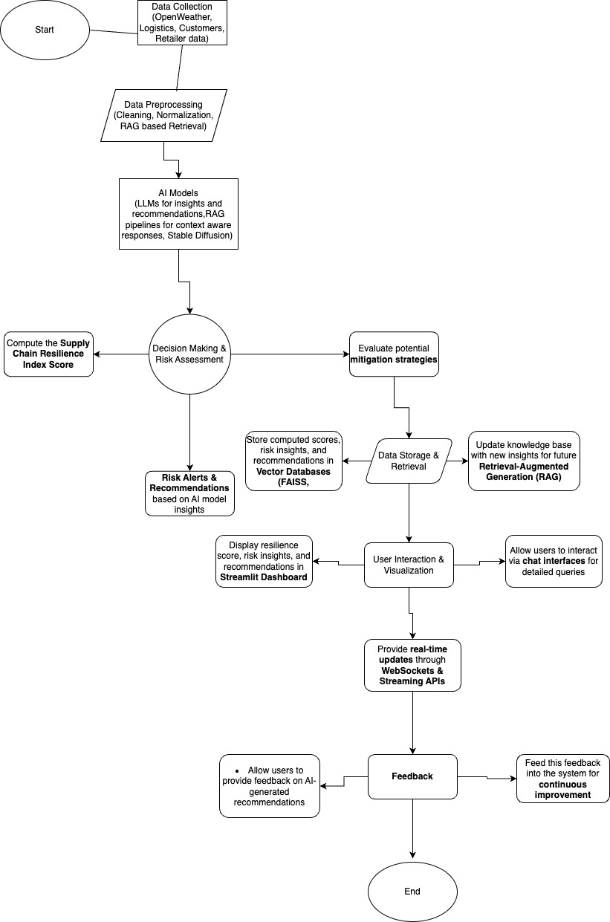

**2.Application Interface (UI/UX) Wireframe:-**

Objective:

Designed wireframes to illustrate how users interact with the system.

**Diagram link:** <https://share.balsamiq.com/c/kNYhGuU55xZWgpxYf3jiTQ.jpg>

This diagram represents an AI-powered supply chain resilience system that optimizes shipping routes based on real-time weather conditions. The system takes user inputs, such as order attributes, processes data using AI models (LLM, RAG, and Stable Diffusion), and stores relevant information in databases, including FAISS and OpenWeather API. The processed data generates optimized routes or alerts about delays, which are displayed on a user dashboard for retailers and logistics providers. The implementation leverages RAG and Streamlit to create an interactive user interface.

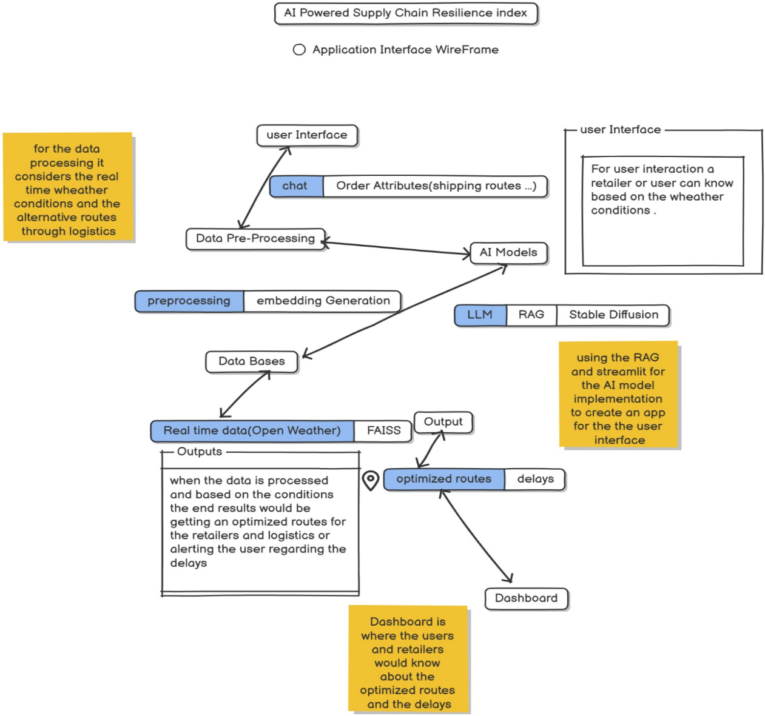

**3.Overall System Architecture Diagram:**

Objective: System’s overall structure, including how AI components and services interact from data input to output delivery.

**Descrption:**

The AI-Powered Supply Chain Resilience System (SCRI) flowchart outlines the end-to-end process of collecting, processing, analyzing, and visualizing supply chain data to assess risks and enhance decision-making. The system begins with data collection from multiple sources, including weather, logistics, and social trends, followed by preprocessing (cleaning, feature engineering, and data augmentation). AI models, such as LSTM forecasting, Transformers, and RAG retrieval, analyze the data to generate risk insights. These insights are processed in the risk analysis and backend services phase, where risks are categorized, resilience scores are computed, and reports are generated. The system offers real-time updates via dashboards and chat interfaces, allowing users to interact with AI-generated insights. Additionally, user feedback is incorporated into the system to refine future predictions, ensuring continuous improvement. The structured flow ensures an efficient, data-driven approach to mitigating supply chain risks and improving operational resilience.

